Help your child learn their times tables!
Online games and support
Interactive Resources - login: beckford password: mathsgames https://interactive-resources.co.uk/
Times tables grid http://www.bbc.co.uk/skillswise/game/ma13tabl-game-tables-grid-find
Camel Times Tables http://www.bbc.co.uk/bitesize/ks1/maths/multiplication/play/
Times Tables lots of ways https://www.timestables.co.uk/
Times Tables against the clock http://learn-timestables.com/
Some advice and more links https://www.mathsisfun.com/tables.html
Topmarks - lots of times tables games https://www.topmarks.co.uk/maths-games/7-11-years/times-tables
Hit the Button – fast recall training https://www.topmarks.co.uk/maths-games/hit-the-button
Print your own worksheets https://www.theschoolrun.com/subject/worksheets/times-tables/all
Challenge game - Factor/Multiple Chain Game https://nrich.maths.org/5468
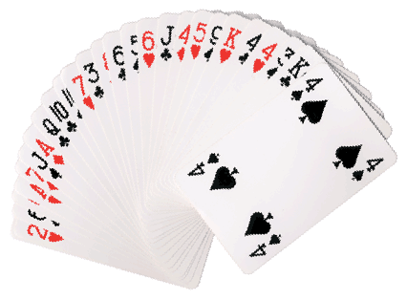

Offline methods
Lego is a great way to teach and use times tables because each brick has a different number of bumps on top. Try counting up in 2s with the 2 bump bricks!
A stack of coins – count in 2ps, 5ps, 10ps, £2s... Can you mix and match? What is the total amount if I have 5 x 10ps and 12 x 2ps?

A pack of cards – take out the aces and Kings, count Jack as 11 and Queen as 12, and you can practise the full range of tables by dealing your child two cards and asking them to multiply them.

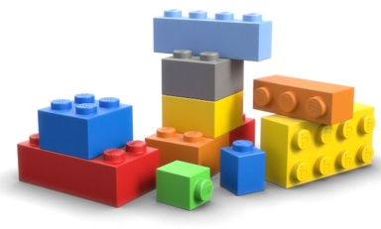
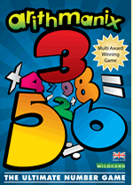
A pack of blank cards - Make them out of cardboard or paper, or buy premade versions from stationery stores. Write the questions and answers on different cards. Shuffle and turn the cards face down. The child has to turn over a card, and then turn over the matching card. This also trains memory! You can start with a small number of sets and build up. How many questions can your child answer correctly against the clock?
Games you can buy - http://www.arithmanix.com/

There are also many apps available. Just search ‘times tables’ on the app store.

Please turn over for a copy of a 12 x 12 multiplication grid. These are the facts children should know by end of Y4.
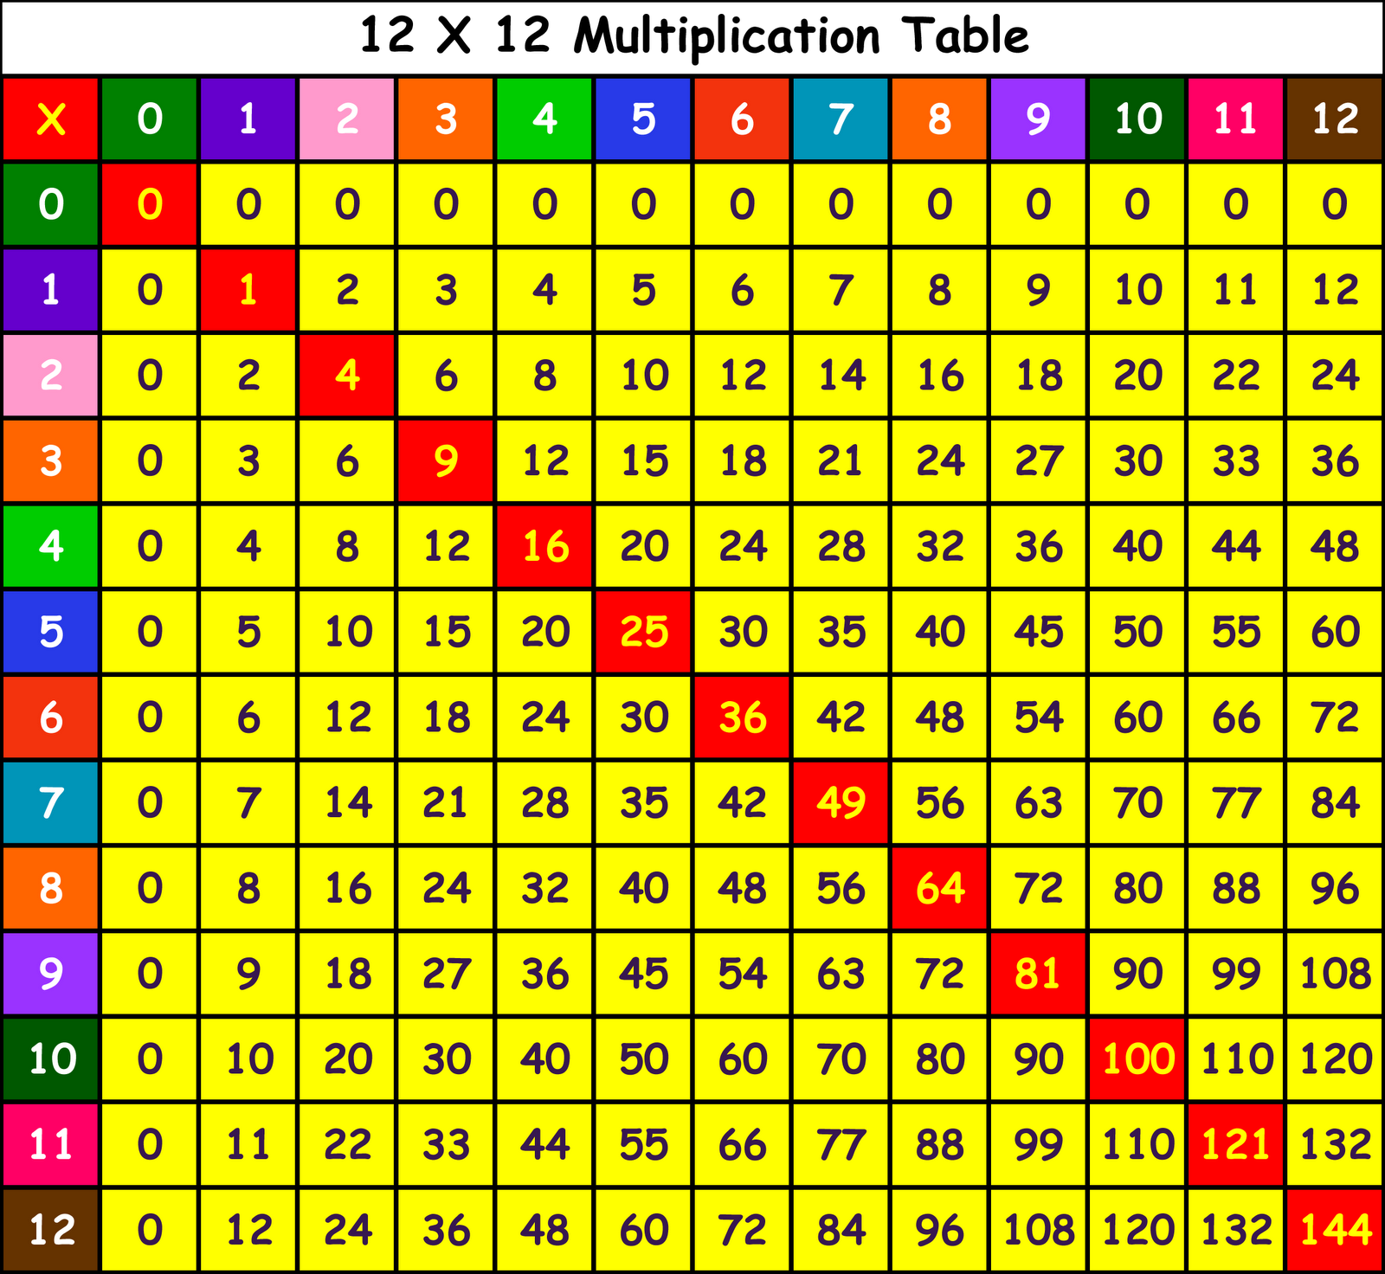

Don’t forget!
- The 6 times table is double the 3s and the 12s are double the 6s.
- The 8 times table is double the 4s.
- If you learn all of your times tables to 11, then you already know the 12s.
- If you find a fact tricky, turn it around and it might be easier! 5 x 7? 7x 5?

