

Educational
Visits
Policy

 | Name |  | Signature |  | Date
Prepared by: | Sophie Keating  Assistant Headteacher |  | 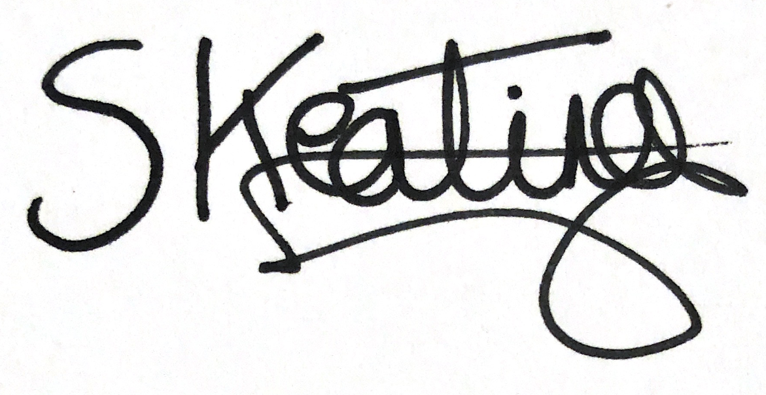 |  | 20.06.25
Checked and Reviewed by: | Sam Drake, Headteacher |  |  |  | 23.6.25
Approved by: | Madhavan Raman Chair of Governors |  |  |  | 2.7.25
Document Title: | Policy – Educational Visits Policy
Version Number: | 1 | Date of Next Review: |  | Summer 2026

Contents
1. Context 3
2. Application 3
3. Types of Visit & Approval 4
4. Roles and responsibilities 4
5. Staff Competence 4
6. Emergency procedures 5
7. Trip Planning Procedure 5
8. Risk Assessment 5
9. Staffing and Supervision 6
10. First Aid 7
11. Parental Consent 7
12. Inclusion 8
13. Charging / funding for visits 8
14. Transport 8
15. Insurance 9
16. Swimming 9
17. Water Margin Activities 9
18. Residential Activities 10
19. Adventurous Activities 10
20. Appendix 1 – Flow chart of trip planning process 10
21. Appendix 2 – Educational Visits Checklist 11
22. Appendix 3 – School Learning Area 11
23. Appendix 4 – Emergency Procedure 13
24. Appendix 5 - Annual Parental Consent Form 13

Context

We believe that educational visits are an integral part of the entitlement of every pupil to an effective and balanced curriculum. Appropriately planned visits are known to enhance learning and improve attainment, and so form a key part of what makes West Hampstead Primary School a supportive and effective learning environment. The benefits to pupils of taking part in visits and learning outside the classroom include, but are not limited to:

- Improvements in their ability to cope with change.
- Increased critical curiosity and resilience.
- Opportunities for meaning making, creativity, developing learning relationships and practicing strategic awareness.
- Increased levels of trust and opportunities to examine the concept of trust (us in them, them in us, them in themselves, them in each other).
- Improved achievement and attainment across a range of curricular subjects. Pupils are active participants not passive consumers and can see their learning ‘in action’.
- Enhanced opportunities for ‘real world’ ‘learning in context’ and the development of the social and emotional aspects of intelligence.
- Increased risk management skills through opportunities for involvement in practical risk-benefit decisions in a range of contexts i.e. encouraging pupils to become more risk aware as opposed to risk averse.
- Greater sense of personal responsibility.
- Possibilities for genuine team working including enhanced communication skills.
- Improved environmental appreciation, knowledge, awareness and understanding of a variety of environments.
- Improved awareness and knowledge of the importance and practices of sustainability.
- Physical skill acquisition and the development of a fit and healthy lifestyle.

Application

Any visit that leaves the school grounds is covered by this policy, whether as part of the curriculum, during school time, or outside the normal school day.

In addition to this Educational Visits Policy, West Hampstead Primary School:
- Adopts the Local Authority’s (LA) document: ‘Guidance for Educational Visits and Related Activities with National Guidance & EVOLVE’ (All staff have access to this via EVOLVE).
- Adopts National Guidance www.oeapng.info (as recommended by the LA).
- Uses EVOLVE, the web-based planning, notification, approval, monitoring and communication system for off-site activities.

All staff are required to plan and execute visits in line with this school policy, Local Authority policy, and National Guidelines. Staff are particularly directed to be familiar with the roles and responsibilities outlined within the guidance.

Types of Visit & Approval

There are three ‘types’ of visit:

Level 1 - Visits/activities within the ‘School Learning Area’ that are part of the normal curriculum and take place during the normal school day.
These follow the ‘School Learning Area’ Operating Procedure (Appendix 1).

Level 2 - Other non-residential visits within the UK that do not involve an adventurous activity. Eg. visits to museums, farms, theme parks, theatres, etc.
These are entered on EVOLVE by the visit leader and then submitted to the Head for approval.

Level 3 - Visits that are overseas, residential, or involve an adventurous activity.
These follow Level 2 above, but the Head then submits the visit to the LA for approval.

For further information on who provides approval in different contexts, see the Approval Flowchart in Appendix 1.

Roles and responsibilities

Visit leaders are responsible for the planning of their visits, and for entering these on EVOLVE (where required). They should complete the Trip Proposal form and send to the Head Teacher EVC, Phase Leader, School Business Manager and School Administrative Officer when they begin planning the trip. Visit leaders have responsibility for ensuring that their visits will comply with all relevant guidance and requirements, and should seek advice from the EVC and Head Teacher where necessary.

The Educational Visits Coordinators (EVC) are Sam Drake and Sophie Keating, who will support and challenge colleagues over visits and learning outside the classroom (LOtC) activities. The EVC is the first point of contact for advice on visit related matters, and will support with creating visit plans on EVOLVE before they are submitted to the Head. The EVC sets up and manages the staff accounts on EVOLVE, and uploads generic school documents, etc.

The Head Teacher has responsibility for authorising all visits and for submitting those that are overseas, residential or adventurous to the LA for approval.

The Governing Body’s role is that of a ‘critical friend’. They seek to enable and ensure high quality visits and outdoor learning take place through supporting and challenging school practice and policies. Individual governors may be given ‘read-only’ access to EVOLVE.

The Local Authority is responsible for the final approval (via EVOLVE) of all visits that are either overseas, residential, and/or involve an adventurous activity.

Staff Competence

We recognise that staff competence is the single most important factor in the safe management of visits, and so we support staff in developing their competence in the following ways:
- An apprenticeship system, where staff new to visits assist and work alongside experienced visit leaders before taking on a leadership role.
- Supervision by senior staff on some educational visits.
- Support for staff to attend training courses relevant to their role, where necessary.
- Providing in house Visit Leader training for members of staff who take on this role.

In deciding whether a member of staff is competent to be a visit leader, the Head Teacher will take into account the following factors:
- Relevant experience.
- Previous relevant training.
- The prospective leader’s ability to make dynamic risk management judgements, and take charge in the event of an emergency.
- Knowledge of the pupils, the venue, and the activities to be undertaken.

It is possible for the Visit Leader role to be undertaken by Teachers, HLTAs and LSAs as long as they meet the above criteria.

Emergency procedures

A critical incident is any incident where events go beyond the normal coping mechanisms and experience of the visit leadership team.

The school has an emergency plan in place to deal with a critical incident during a visit (see Appendix 4). All staff on visits are familiar with this plan and it is tested at least bi-annually and following any major staffing changes.

When an incident overwhelms the establishment’s emergency response capability, or where it involves serious injury or fatality, or where it is likely to attract media attention then assistance will be sought from the local authority.

Trip Planning Procedure

The school has a clear planning process that ensures that trips are organised effectively and with careful consideration of the possible risks (see Appendix 1 – Flow chart of trip planning procedure). All staff are informed of this procedure during their Visit Leader Training.

Stage 1 – Trip Proposal Form (submitted at least 4 weeks prior to the trip)
The Visit Leader completes a Trip Proposal form when they begin planning the trip. This should be sent to the Head Teacher, EVC, Phase Leader, School Business Manager and School Administrative Officer. For ease, these emails are included in the ‘Trips’ group on the school Gmail system.

This form requires teachers to provide the following information:
- Location
- Date
- Children and adults attending, including key children requiring additional support
- Cost
- Transport plans
- Lunches required

Stage 2 – Informing parents of the trip (at least 3 weeks prior to the trip)
Parents should be informed of the trip via email and consent sought if needed. For full details, see Section 11 – Parental Consent.

Stage 3 – Complete Visit Form on Evolve (submitted at least 1 week prior to the trip)
The Visit Leader completes the Visit Form on Evolve, including their Event Specific Notes Form. For the school’s approach to risk assessment, see Section 8.

Stage 4 – Briefing children, staff and volunteers
Before leaving school, visit leaders should ensure that everyone attending the trip, including children, have been clearly briefed on their role and the expectations for behaviour. The school’s behaviour policy is still in place when children are off site for an educational visit.
Staff should use the following template documents to support this process:
- Briefing slides for class
- Briefing sheet for school adults
- Briefing sheet for parent helpers

Risk Assessment

The school has two levels of documentation used to identify and manage risks during school visits.

Educational Visits Checklist
West Hampstead Primary School’s Educational Visits Checklist is part of the risk management process for visits and off-site activities, and may be downloaded from EVOLVE Resources or found on the School Shared Area (see Appendix 2). This has been adapted from the LA’s generic checklist. A visit should only go ahead if the answer to all relevant questions is ‘YES’.
This document does not need to be submitted to Evolve but does need to be carefully considered by the visit leader and all actions taken before the visit takes place. This does not apply to trips in the School Learning Area, as long as they meet the criteria set out in Appendix 3 and the standard operating procedure is followed.

Event specific documents
These record the specific risks or issues for a particular visit that are not covered by Educational Visits Checklist. As a school, we use:
- Event Specific Notes Form – This is completed by visit leaders to identify any additional risks and actions used to mitigate these.
- Trip Contract – These are completed for individual children who need additional support with behavior during a school visit. They are used to support positive behavior and identify how any risks will be mitigated.

It is not possible to eliminate all risks, but they should be balanced to an acceptable or tolerable level. Planning should balance the potential risks with the intended benefits and outcomes of the activity.

Teachers should ideally visit the venue in advance to identify possible risks. Where this is not practical, the visit leader must seek guidance from members of staff at the venue to support with the risk assessment process.
Risk assessment is a dynamic process, which is ongoing throughout a visit. The ongoing monitoring of all aspects of the visit by the leader and accompanying staff is an essential aspect in the risk management of visits, and therefore the safety of participants. Risks should be monitored throughout the visit and where appropriate activities should be modified or curtailed to suit a change in circumstances. This is primarily the responsibility of the visit leader, in consultation with other staff.

Staffing and Supervision

On all visits there must be an ‘effective level of supervision’ that has been approved by the EVC and Head Teacher, in accordance with LA and National guidance and school policy.

For Nursery and Reception classes (EYFS)
The Statutory Framework for the EYFS no longer differentiates between outings and on-site settings regarding minimum specific ratios. The appropriate ratio during an EYFS outing is likely to be higher than the minimum and should be determined by risk assessment prior to the trip.

For Years 1-6
There is no specified ratio for the staffing of trips. The following factors will be taken into consideration when deciding the number and suitability of staffing:
- Type, level and duration of the activity
- The support required by individual children within the group, including those with additional educational or behavioral needs
- The experience and competence of staff and other adults
- The venue, time of year and weather conditions
- The contingency or ‘Plan B’ options

There should always be a member of school staff with the class or group. Other responsible adults can include volunteers or students working at West Hampstead, parents or other responsible adults well known to the school.

A visit must not go ahead if the visit leader, EVC or Head Teacher is not satisfied that an appropriate level of supervision exists.

First Aid

For all visits there should be a responsible adult with a good working knowledge of first aid appropriate to the environment. This will mean that one or more members of staff:
- Have a working knowledge of simple first aid and is competent to use the first aid materials carried with the group
- Knows how to access, and is able to access, qualified first aid support

For visits involving EYFS children, there is a statutory requirement that at least one person has a current paediatric first aid certificate and sufficient use and understanding of English to summon help in the event of emergency.

When deciding the level of First Aid support required, the following aspects should be considered:
- The nature of the activity
- The nature of the group
- The likely injuries associated with an activity
- The extent to which the group will be isolated from the support of the emergency services (both in terms of distance and response time)

A first aid kit appropriate to the visit should always be carried. Any children with individual healthcare plans or specific medical requirements should have access to their medication and a sufficient number of trained people should be available to administer this medication.

Parental Consent

Consent is not required for Level 1 visits, which are activities within the School Learning Area that are part of the normal curriculum during normal school time.

The school obtains blanket consent at the start of each year for routine Level 2 visits e.g. trips outside of the School Learning Area to museums or places of interest and after school fixtures. Parents provide consent via the Scopay app. It is also possible for parents to consent via a traditional paper form if requested. (See Appendix 5.)

Parents will then be informed at least 3 weeks in advance of any visit taking place (or as soon as possible if the visit is organised at short notice). This includes visits within the School Learning Area. They must be given information about the visit and their child’s proposed participation and given the opportunity to withdraw their consent should they not wish them to participate. This can also be used as an opportunity to remind parents of consent previously given. Where using a third-party provider, parents should be informed about the provider. This can be by providing the provider’s website address. For visits that require payment from parents, see Section 13.

Specific, (ie. one-off), parental consent must be obtained for Level 3 visits and some Level 2 visits. For these visits, sufficient information must be made available to parents (via Scopay, letters, meetings, etc), so that consent is given on a ‘fully informed’ basis. As above, parents have the option of consenting online via, or through a traditional paper consent form.

Visits that will always require parental consent include:
- Any visit involving Nursery age children
- Visits including adventurous activities
- Residential visits
- Visits where we are required to use a provider’s consent form

This procedure is in line with the OEAP’s guidance 4.3d Parental Consent and Informing Parents.

Inclusion

Under the Equality Act 2010, it is unlawful to discriminate against disabled participants because of their disability, without material or substantial justification. Off site visits should be available and accessible to all, irrespective of any special educational or medical needs or protected characteristics. We are required to make reasonable adjustments to avoid participants being placed at a substantial disadvantage.

A decision to exclude a child from a trip should not be taken lightly and only after consultation with the Head Teacher, visit leader, class teacher, SENCO, parents and any other relevant parties. If a child is not able to participate, a suitable alternative should be considered.

Behaviour is not one of the protected characteristics defined by the Equality Act. It may therefore be reasonable to exclude a child from an activity or visit if their potential behaviour presents a significant, unmanageable and unacceptable risk to the health, safety or welfare of either themselves or others, or to the successful completion of the activity or visit. For any child who presents challenging behaviour, it may be helpful for the Phase Leader, SENCO and class teacher to use a ‘Trip Contract’ to support positive behaviour and identify how any risks will be mitigated.

Charging / funding for visits

As a school, we recognise that legislation prohibits charges for educational visits both during and outside school hours that are part of the National Curriculum. Parents may be invited to make a voluntary contribution for activities which are used to expand and enrich children’s experiences. These contributions are genuinely voluntary and pupils will not be excluded from any activity if their parents are unable to pay. For further information, please see our Charging Policy.

In order to support the school to continue to fund educational visits and enrichment opportunities, parents will be invited to make an annual voluntary contribution at the start of each year. This will support the school to plan for any costs associated with these events.

The school also utilises funding from other sources to subsidise the cost of trips where possible.

Transport

West Hampstead Primary School follows National Guidance for the use of transport during educational visits (see 4.5a Transport general considerations).

In deciding where to go and how to travel, staff should consider the cost, convenience and safety of particular modes of transport alongside any environmental impacts and implications for accessibility. The level of supervision should also be considered as part of the risk management process. Whatever the mode of transport, staff should ensure that group members are aware of emergency procedures and alternative routes in the event of delay or cancellation.

All members of staff on a visit should be briefed on a common approach for managing road crossings. Where available, pedestrian crossings, traffic lights, underpasses and footbridges should be used. All members of staff should be aware of and follow the Green Cross Code.

Coaches

The LA does not ‘approve’ coach companies. UK legislations ensures that coach companies are fit for public use but facilities available on coaches may vary.

Refer to National Guidance document 4.5e Hiring a coach

Public transport

Transport for London offer free travel for school parties on public transport.

All members of staff on a visit should be briefed on how to safely supervise children on public transport. These measures include:
- Arriving on time and waiting for transport in a safe place
- Conducting a head count whenever a group if getting on and off public transport
- Ensuring a member of staff is the last person on or off any public transport
- Ensuring children are effectively supervised while on public transport and within sight of a member of staff – where possible, children should stay seated while travelling and not kneel or stand on the seats
- Ensure children stay clear of the doors after boarding or leaving transport
- Informing children to tell a member of staff if they feel unwell

Use of staff cars to transport pupils

The school follows LA guidance on the use of staff cars. Where a private (staff or parent) car is to be used to transport children then this must be approved by the Head Teacher and a ‘Private Car Form’ must be completed and retained by the school (on an annual basis if appropriate).

Refer to National Guidance document 4.5c Transport in private cars

Insurance

The school follows the Camden policy regarding insurance arrangements for educational visits. We obtain specific insurance cover from Camden for any residential trips that take place.

Swimming

Swimming Lessons
Swimming lessons are part of our National Curriculum. It is the role of the Headteacher to ensure that teachers expected to undertake swimming teaching activities will have the experience and confidence which is appropriate for the level of swimming instruction and appropriate qualifications where necessary. This is also covered in the WHPS Health and Safety Policy.

During swimming lessons, the school’s staff do not have responsibility for lifeguarding. However, they do retain a pastoral role for participants at all times. School staff should brief children on behaviour expectations, including no running, dangers around steps, any hazards from slipping and whether diving is permitted.

Other trips involving swimming activities
For other visits involving swimming, the visit leader should refer to the LA guidance. LA approval is not required for trips to UK swimming pools that are lifeguarded. For any open water swimming activity, LA approval is required via EVOLVE.

Water Margin Activities

This section applies to activities that take place in or near water – such as a walk along a riverbank or seashore, collecting samples from ponds or streams, or paddling or walking in shallow, gentle water.

If the activity exceeds this definition then it is classed as a water-based adventurous activity needing local authority approval.

If the activity falls within this definition, this is classed as a water margin activity and the following applies:
- All staff should know and adhere to the National Guidance document 7i Group safety at water margins. This document must be made available to all supervising adults in advance of the visit.
- Staff should ensure that the intended outcomes are balanced with all reasonably practical safety precautions.
- Where appropriate, there should be an approved alternative ‘Plan B’ that could be used in adverse conditions.
- The visit leader must have previous relevant experience and have been assessed as competent to lead the activity by the Head Teacher.

Residential Activities

All residential activities are Level 3 visits and must be submitted to the LA for approval. Visit leaders should refer to the National Guidance document 4.2b Residential Visits.

Adventurous Activities

LA and National guidance sets out the definition of an adventurous activity.

Most types of visits carried out at school are not adventurous activities, these include:
- Walking in parks or non-remote country paths
- Swimming in publicly lifeguarded pools
- Theme parks
- Tourist attractions
- Farm visits
- Museums, libraries etc
- Physical education and sports fixtures
- Water margin activities

The responsibility for the safety of participants in an adventurous activity will rest with either an external provider or a member of school staff, who is specifically approved to lead the activity. Any external provider must hold an LOtC Quality Badge or complete a Provider Form, which is uploaded to Evolve.

Appendix 1 – Approval Flowchart
This flowchart is taken from Camden’s document ‘Guidance for Off-Site Visits and Related Activities’ (2022). This document is available on Evolve and the School Shared Area. The sections referenced below refer to that document, which should be consulted for further guidance if needed.
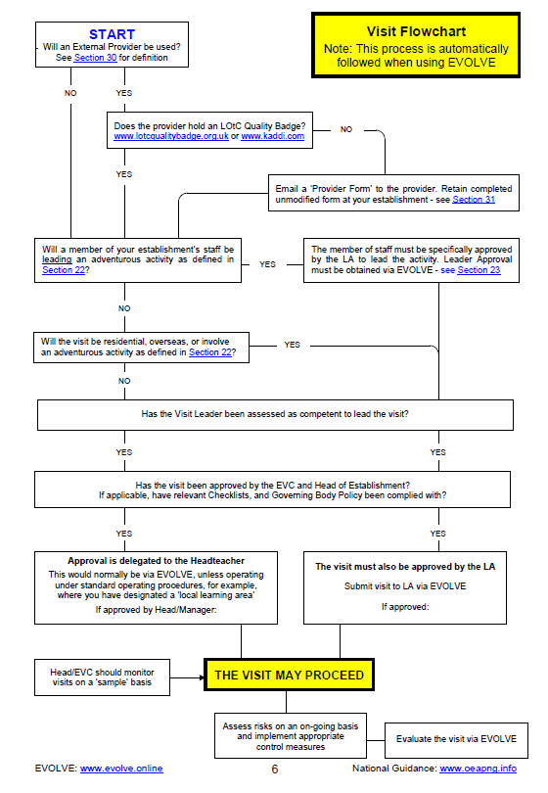

Appendix 2 – Educational Visits Checklist

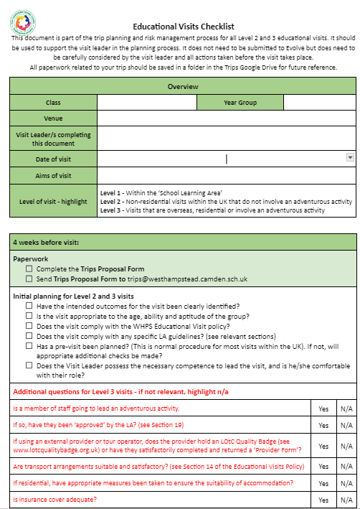
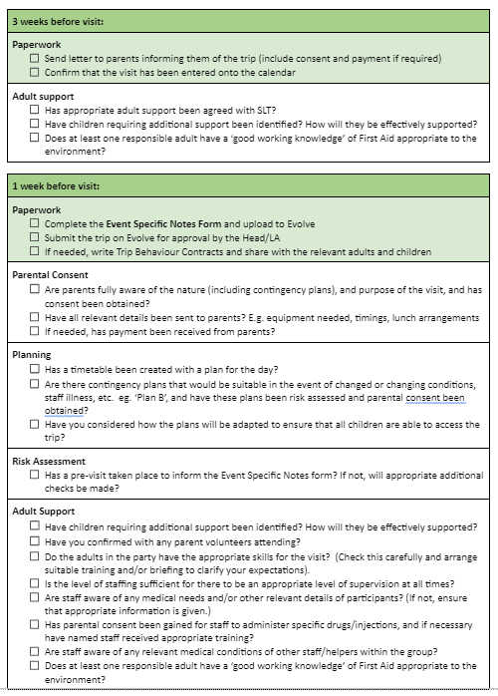
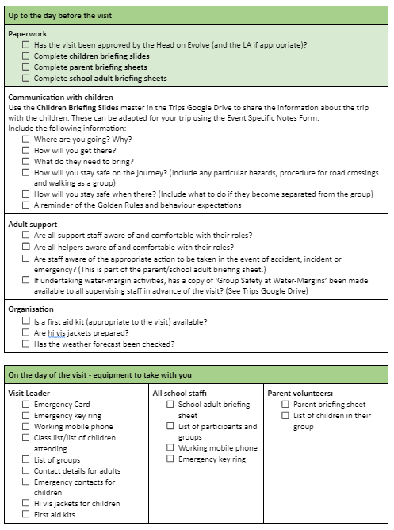

Appendix 3 – School Learning Area

General

Visits/activities within the ‘School Learning Area’ that are part of the normal curriculum and take place during the normal school day follow the Operating Procedure below.

These visits/activities:
- do not require parental consent but parents must be informed that the activity is taking place. If the activity is regular or happening more than once, it may be reasonable to inform parents once at the start of term of all the of the dates.
- do not normally need additional risk assessments / notes (other than following the Operating Procedure below).
- should be recorded in the school ‘Signing Out Book’ when leaving and returning. The information required includes the date, visit leader and other members of staff/volunteers, year group, class, number of children, venue and the time out and back. The visit leader must also tick to confirm that they are taking with them the emergency cards, a first aid kit and a working mobile phone.

Boundaries

The boundaries of the School Learning Area are shown on the map below.

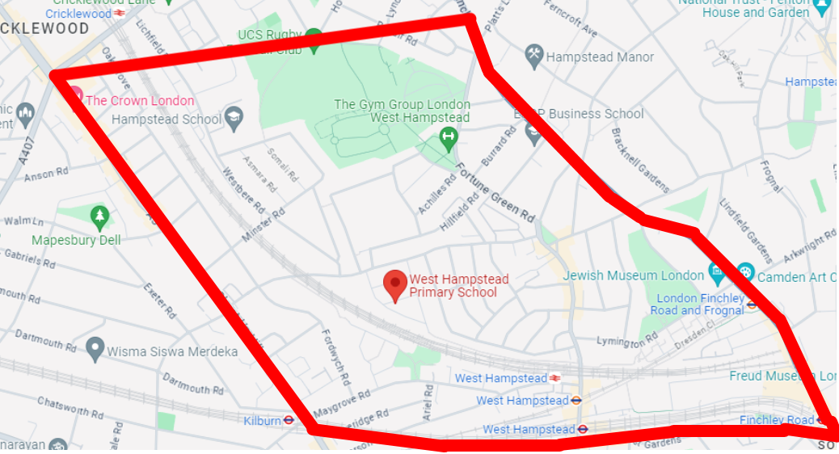

This area includes, but is not limited to, the following frequently used venues:
- Hampstead School
- Westbere Copse
- West Hampstead Library
- Fortune Green

Operating Procedure for School Learning Area

The following are potentially significant issues/hazards within our School Learning Area:
- Road traffic.
- Other people / members of the public / animals.
- Losing a pupil.
- Uneven surfaces and slips, trips, and falls.
- Weather conditions.
- Activity specific issues when carrying out activities in Westbere Copse and other areas (nettles, brambles, rubbish, etc).

These are managed by a combination of the following:
- The Head must give verbal approval before a group leaves.
- Only staff judged competent to supervise groups in this environment are approved. A current list of approved staff is maintained by the EVC and office.
- The concept and Operating Procedure of the ‘School Learning Area’ is explained to all new parents when their child joins the school and is included in our annual parental consent form.
- There will normally be a minimum of two adults. This will be confirmed with the Head when seeking verbal approval.
- Any children with additional SEN or behaviour needs have the required support to ensure they are safe. This should be discussed with the Head before leaving. If it is deemed necessary, a ‘Trip Contract’ can be used to support.
- Staff are familiar with the area, including any ‘no go areas’, and have practiced appropriate group management techniques.
- Pupils have been trained and have practiced standard techniques for road crossings in a group.
- Where appropriate, pupils are fully briefed on what to do if they become separated from the group.
- Pupils’ clothing and footwear is checked for appropriateness prior to leaving school.
- Staff are aware of any relevant pupil medical information and ensure that any required medication is available.
- Staff complete the ‘Signing Out Book’ in the office upon leaving and returning.
- A working mobile phone is taken with each group and the office have a note of the number.
- Appropriate personal protective equipment is taken when needed (eg gloves, goggles)
- Pelican crossings, zebra crossings and lights are used wherever possible.
- Any volunteers or additional adults are clearly briefed on their roles and responsibilities, particularly when crossing roads.
- Staff remain vigilant of hazards in the area when children are carrying out activities and brief children as necessary e.g. rubbish, nettles, brambles or other hazards.

Appendix 4 – Emergency Procedure

The school’s emergency response to an incident is based on the following key factors:

- There is always a nominated emergency base contact for any visit (during school hours this is the office).
- This nominated base contact will either be an experienced member of the senior management team, or will be able to contact an experienced senior manager at all times. They will have access to Evolve. If this is not possible, then they should have an Emergency Card (Home Contacts) available at all times.
- For activities that take place during normal school hours, the visit leadership team will be aware of any relevant medical information for all participants, including staff.
- For activities that take place outside normal school hours, the visit leadership team and the emergency contact/s will be aware of any relevant medical information and emergency contact information for all participants, including staff.
- The visit leader/s and the base contact/s know to request support from the local authority in the event that an incident overwhelms the establishment’s emergency response capability, involves serious injury or fatality, or where it is likely to attract media attention. All vi
- For visits that take place outside the School Learning Area, the visit leader will carry an LA Emergency ‘Card’ (see EVOLVE Resources or Staff Shared Area)
The visit leader and any other staff who will be supervising groups of children will also carry an EVOLVE Emergency Pocket Guide.
- This Emergency Procedure is tested through both desk top exercises and periodic scenario calls from visit leaders.

This will come into effect from Autumn 2025.
This will come into effect from Autumn 2025.

