Progression in Science at WHPS
Depending on the year group you visit, science might look very different at WHPS. As your child goes through school, the way they learn science changes and the challenges get higher.
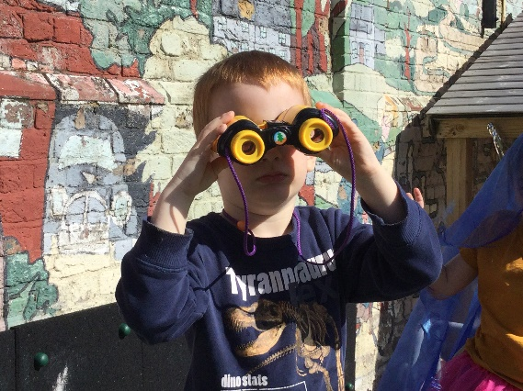
For our youngest children in the nursery and reception, science is learnt through play, stories and songs. They observe, ask questions and learn new words, developing their knowledge and understanding of the world. Recently they have learnt about the seasons.
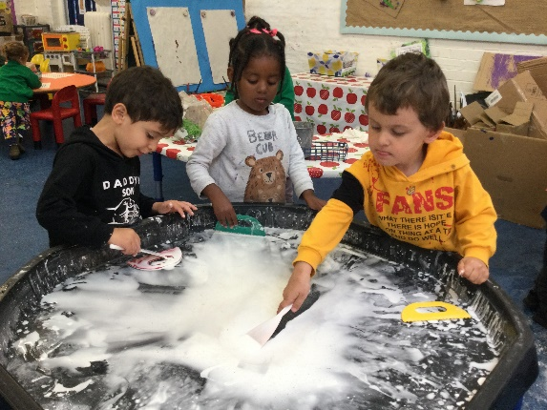

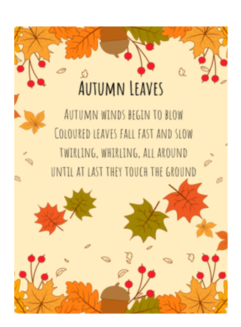
In year 1, they have been learning about themselves, their senses and their bodies. This has been part of their integrated day activities.
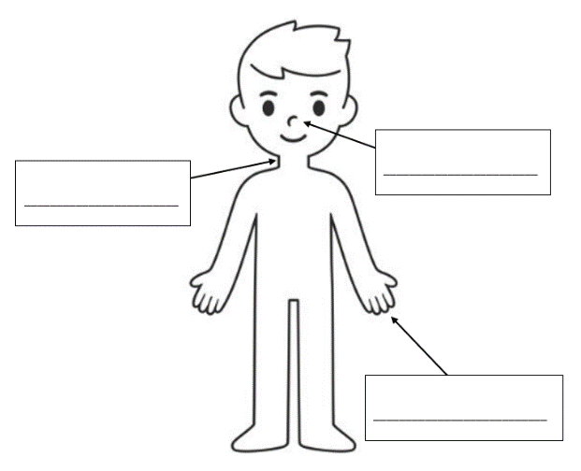

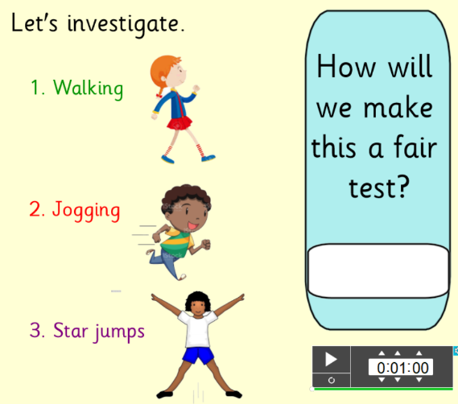
In Year 2, science lessons become more formal. This term the science topic was Animals Including humans. They have been investigating what happens to our bodies when we exercise.

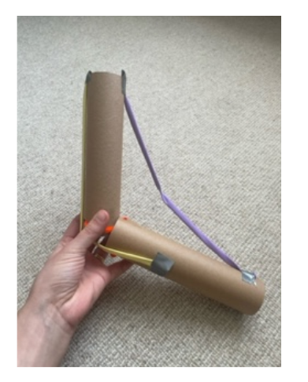
In year 3, they have been learning about muscles and bones. They even made models of muscles using cardboard tubes and elastic bands.

Year 4 have been building electrical circuits and learning about conductors (materials which conduct electricity) and insulators (materials which don’t conduct electricity.)
Their next topic is Teeth, and they have been investigating what damages tooth enamel.
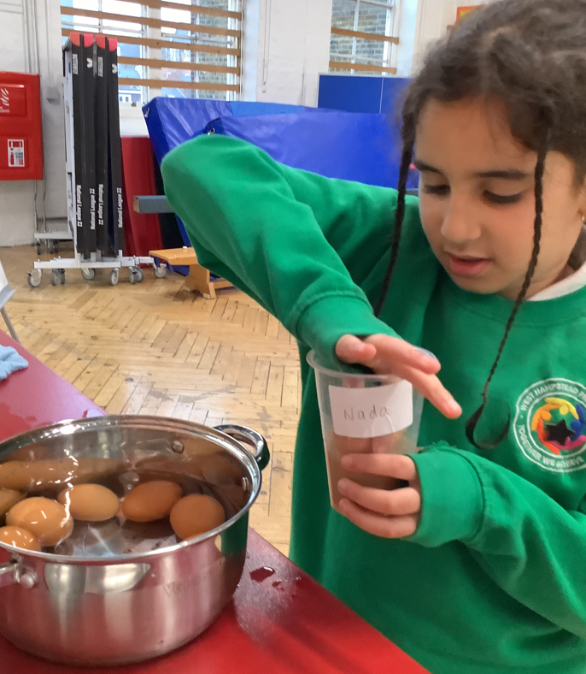
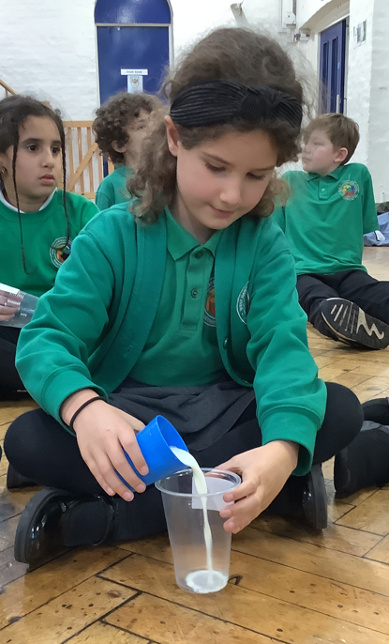

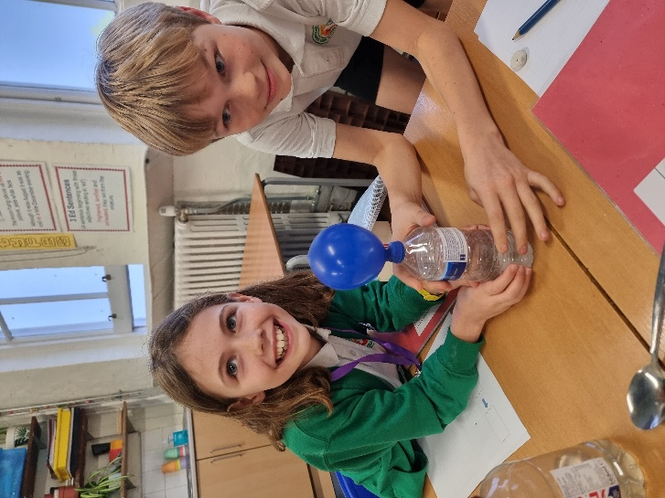
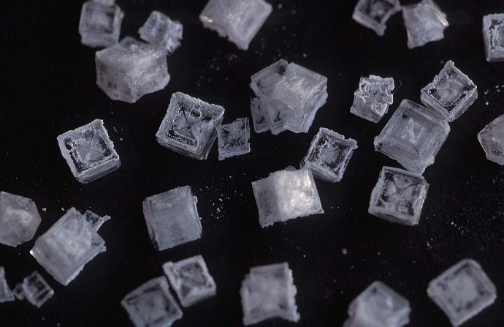
Year 5 are investigating the properties of materials and recently made super saturated salt and sugar solutions. They then left the solutions and found that the water evaporated, leaving salt and sugar crystals behind.

They also found out about irreversible changes, such as mixing bicarbonate of soda and vinegar to produce a gas called carbon dioxide.

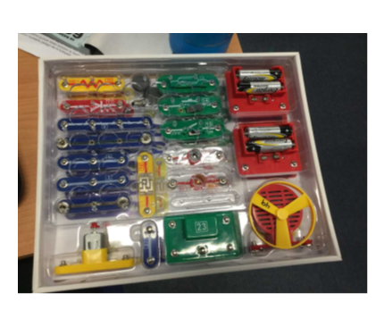
Year 6 have been building circuits using kits lent to us by the Crick Institute. They have also been learning about Alessandro Volta, the inventor of the first battery.

As you can see, we try to make sure that, as children move through the school:
- The learning suits their stage of development
- Their knowledge becomes wider and deeper, by revisiting ideas at a higher level.
- Their science skills are developed
- Their science vocabulary is built up
But most importantly, their science lessons are exciting and fun.

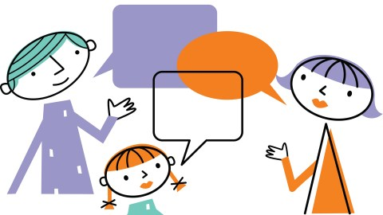
Why not ask your child about their science learning?

