The West Hampstead Curriculum - A Guide for Parents in Reception
This document shows you what children in Reception will be learning throughout the year and what your child will be learning in the Summer term. You will receive more information later in the year.
Intent - The West Hampstead Curriculum is designed to:
- Teach our pupils to learn well
- Teach our pupils how to lead happy, healthy, constructive lives, in which they can aspire and experience success
- Ensure broad and balanced knowledge of the world
- Ensure high levels of competence in the core subjects of English and maths
- Teach our pupils to live well in a diverse world, as confident, responsible citizens

West Hampstead Values:
The children, staff, parents and governors have worked together to develop our five core West Hampstead values , Aspiration, Responsibility, Resilience, Consideration and Community. These themes run through each of our topics.
EYFS Curriculum:
The EYFS curriculum uses a broad selection of engaging core texts linked each half term to an overarching theme. The activities and experiences we plan are guided by the Educational Programmes set out in the DFE Statutory framework for the early years foundation stage and designed to enable all children to acquire the skills, knowledge and attitudes they will need by the end of the reception year.
The National Curriculum:
At our school the National Curriculum is statutory. It lays out the range of subjects we must teach and sets the standards pupils are expected to reach at the end of each key stage of learning. Our Schools Curriculum incorporates the National Curriculum and goes beyond it. We have adapted and extended the National Curriculum to meet the particular needs of our pupils and families. It is a curriculum designed to work for all in our community.
Topic Enrichment We believe that all topics should be memorable, engaging and exciting! Our curriculum is enriched with additional experiences, trips and events to enhance the learning that goes on in our school.
If you have any questions about the curriculum, please contact: admin@westhampstead.camden.sch.uk

The Values | Aspiration   | Responsibility  
 | - Creativity  - Curiosity  - Communication | - Citizenship  - Staying Healthy  - Organisation
Resilience   | Consideration   | Community  
- Confidence  - Independence  - Adaptable | - Kindness  - Empathy  - Respect | - Belonging  - Collaboration  - Relationships
Reception- West Hampstead Curriculum Overview
West Hampstead Curriculum
Reception
Summer 1  Once Upon a Time  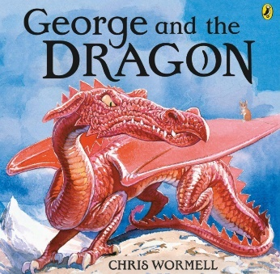  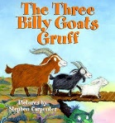 |  |  | Summer 2  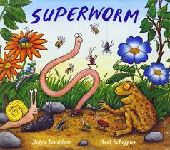  In Our Magical Garden  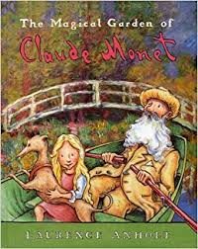  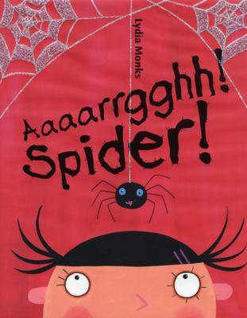
Our School Values
Aspiration | Responsibility | Resilience   |  | Consideration | Community
Our five core WHPS values are Aspiration, Responsibility, Resilience, Consideration and Community. We will develop these values where they link into our topics through stories, discussion and circle times.
Our topic themes are carefully selected to expose all children to a wide range of ideas, language, learning opportunities and experiences. This enables them to make connections in their learning as well as providing a springboard to ignite their imagination, curiosity and creativity.
Every unique child will access these learning opportunities at their own level and make progress from their own starting points. Key thinking and learning skills linking to the prime areas of learning are developed through all topics.
Reception Curriculum Map for Parents – Summer Term
PERSONAL, SOCIAL, EMOTIONAL DEVELOPMENT
Summer 1: Relationships – understanding my own feelings, understanding how others feel, thinking about what is fair and unfair and how we can make things fair. What can help you to feel better if you are feeling sad or missing someone?
Summer 2: Change – how have we changed since the start of Nursery/Reception? How does change make us feel? Getting ready for Year 1! Thinking about what will be the same and what will be different
- Model and praise following the Golden Rules.
- Use the Zones of Regulation to think about our feelings and the feelings of others.
- Developing independence for Year 1.
- Read and share books with PSED themes, and allow children to access these independently in the book corner.
- Working on building determination and resilience. Linking to ‘mistakes are marvellous’ which help us learn what to do next time.
- We will continue to link PSED themes to the key texts we are reading.
PHYSICAL DEVELOPMENT
Fine-motor skills:  - Continue to develop accurate letter formation through whole class phonic sessions, small groups and a range of fine motor activities.  - Activities to develop cutting and joining skills  - Painting with attention to detail | Gross-motor skills:  PE sessions with Mr Leer including Games, balancing, catching and throwing, and gymnastics.  - Sports Day activities  - Obstacle courses and building dens and bridges  - Forest School
COMMUNICATION AND LANGUAGE
- Retell and act out familiar stories to develop story language, phrasing and learn new vocabulary.
- Creating and telling our own stories using story language and conjunctions such as first, next, then, after that, finally. Acting out our stories.
- Introduce hot seating of characters from core texts – encourage children to ask and answer questions in role.
- Developing our ability to offer more detailed explanations, give and follow a series of instructions.
- Introduce simple debates to talk about likes and dislikes and give reasons. Do you agree or disagree with someone else and can you say why.
- The role of builder in a discussion - Can you build on what someone else has said?
- Learning new BSL signs with Rebekah Hort that links to our topics.
- Learning new vocabulary everyday as ‘WOW’ words.
LITERACY
Reading:  - Little Wandle Letters and Sounds Phonics Phase 4 – daily phonics sessions introducing reading words with adjacent consonants, longer words, a range of endings including -ing/-ed/-est/-t/-es/-s/-id and new tricky words.  - Three times weekly guided reading groups to develop word reading, fluency and comprehension.  - Two reading books sent home each week matched to phonics taught in class to practise reading skills further and develop confidence.  - Lots of reading for pleasure e.g. in book corners and at whole class story time.  - Exploration of characters, setting and events in relation to our core texts.  - Making story maps to support our own story telling skills and understanding the structure of stories. | Writing:  - Practise spelling of newly taught words in phonics sessions.  - Focus on composing and writing simple sentences with greater independence matching spoken words with written words.  - Continue to develop writing for enjoyable and meaningful purposes throughout the day.  - Moving on to developing storytelling skills – story maps and beginning to extend writing.  - Write a character description. (Core text: George and the dragon & Three Billy Goats Gruff)  - Begin to write a simple recount about forest school.  - Factual writing about minibeasts.
MATHEMATICS
NCETM Overview for Summer 1 & 2
Subitising (encouraging our children to, “See the amount - don’t count” when working with smaller quantities of objects)
- Continue to practice increasingly familiar subitising arrangements, including those which expose ‘1 more’ or ‘doubles’ patterns.
- Use subitising skills to enable the children to identify when patterns show the same number but in a different arrangement, or when patterns are similar but have a different number.
- Subitise structured and unstructured patterns, including those which show numbers within 10, in relation to 5 and 10.
- Identify when it is appropriate to count and when groups can be subitised.
Cardinality, ordinality and counting
- Continue to develop verbal counting to 20 and beyond, including counting from different starting numbers.
- Continue to develop confidence and accuracy in both verbal and object counting.
- Understanding and developing different strategies for counting larger amounts.
Composition
- Explore the composition of 10.
- Make representations of numbers using fingers and ten frames to support understanding of composition
- Focus on doubles and halving
Comparison
- Order sets of objects, linking this to their understanding of the ordinal number system.
Shape and Pattern: sorting 2D and 3D shapes using their properties, using shapes to create and continue patterns.
Measures: comparing weight, length and capacity and having a go at measuring using non-standard units.
UNDERSTANDING THE WORLD
People and Communities
- Festivals and customs.
- Who do we know who can help us? Talk about aspirations and different occupations: what do we want to be when we grow up? (Vets Day)
The World
- Seasonal Changes –How has the tree in our playground changed through autumn, winter, spring and summer?
- Learn about the lifecycle of a butterfly (caterpillars and chicks in class)
- Learning about minibeasts (Visit from some minibeasts).
- Planting and growing plants in the classroom and playground garden
- Visits to Forest School at Westbere Copse
- Mountain goats – where do they live? What else can we find out?
Bridges – how are they useful? Interesting bridges around the world.
Can you build a bridge? (Core texts: The Three Billy Goats Gruff)

Past and Present
- Change – see PSED also. Our own history, how have we changed since Nursery, across the year and what are our hopes for Year 1.
- Claude Monet – Look at the Artist. Can we place him on our timeline?
EXPRESSIVE ART AND DESIGN
Summer 1 – Once Upon a Time
Miss Schafer’s Art lessons:
- Designing dragons!
- Making models of the dragon using clay.
- Make a habitat for a clay model.

Summer 2 – In my Magical Garden
Miss Schafer’s Art lessons:
- Artist study – Claude Monet and make comparisons to other artists.
- Use watercolours/oil pastels to create Monet-inspired art
- Painting flowers using watercolours.

- Share a range of Monet’s paintings, which do we like best and why?
- 3D – making Monet’s magical garden
- Use pastels to create a still-life picture of a flower
- Making close observational studies of minibeasts

Additional Expressive Art and Design:
- Continue to develop a repertoire of songs and rhymes.
- A focus on story telling skills and acting out our stories.
- End of year celebration performance.

