The West Hampstead Curriculum - A Guide for Parents in Reception
This document shows you what children in Reception will be learning throughout the year and what your child will be learning in the Autumn term. You will receive more information later in the year.
Intent - The West Hampstead Curriculum is designed to:
- Teach our pupils to learn well
- Teach our pupils how to lead happy, healthy, constructive lives, in which they can aspire and experience success
- Ensure broad and balanced knowledge of the world
- Ensure high levels of competence in the core subjects of English and maths
- Teach our pupils to live well in a diverse world, as confident, responsible citizens

West Hampstead Values:
The children, staff, parents and governors have worked together to develop our five core West Hampstead values , Aspiration, Responsibility, Resilience, Consideration and Community. These themes run through each of our topics.
EYFS Curriculum:
The EYFS curriculum uses a broad selection of engaging core texts linked each half term to an overarching theme. The activities and experiences we plan are guided by the Educational Programmes set out in the DFE Statutory framework for the early years foundation stage and designed to enable all children to acquire the skills, knowledge and attitudes they will need by the end of the reception year.
The National Curriculum:
At our school the National Curriculum is statutory. It lays out the range of subjects we must teach and sets the standards pupils are expected to reach at the end of each key stage of learning. Our Schools Curriculum incorporates the National Curriculum and goes beyond it. We have adapted and extended the National Curriculum to meet the particular needs of our pupils and families. It is a curriculum designed to work for all in our community.
Topic Enrichment We believe that all topics should be memorable, engaging and exciting! Our curriculum is enriched with additional experiences, trips and events to enhance the learning that goes on in our school.
If you have any questions about the curriculum, please contact: admin@westhampstead.camden.sch.uk

The Values | Aspiration   | Responsibility  
 | - Creativity  - Curiosity  - Communication | - Citizenship  - Staying Healthy  - Organisation
Resilience   | Consideration   | Community  
- Confidence  - Independence  - Adaptable | - Kindness  - Empathy  - Respect | - Belonging  - Collaboration  - Relationships
Reception- West Hampstead Curriculum Overview
West Hampstead Curriculum |  |  | Reception
Me and My Little World  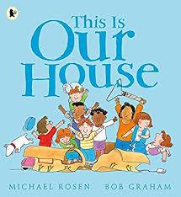  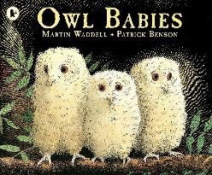  Autumn 1  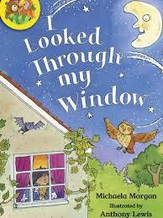  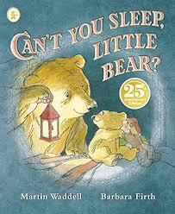 |  |  | Night Time Stories  Autumn 2  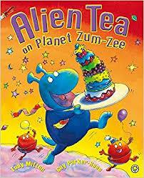  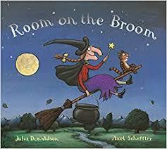  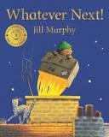
Our School Values

Aspiration | Responsibility | Resilience   |  | Consideration | Community
Our five core WHPS values are Aspiration, Responsibility, Resilience, Consideration and Community. We will develop these values where they link into our topics through stories, discussion and circle times.
Our topic themes are carefully selected to expose all children to a wide range of ideas and knowledge, rich language, learning opportunities and experiences. This enables them to make connections in their learning as well as providing a springboard to ignite their imagination, curiosity and creativity.
Every unique child will access these learning opportunities at their own level and make progress from their own starting points. Key thinking and learning skills linking to the prime areas of learning are developed through all topics.
Reception Curriculum Map for Parents– Autumn Term
PERSONAL, SOCIAL, EMOTIONAL DEVELOPMENT
- Settling in.
- Becoming familiar with class routines. Exploring our new setting; tour of the school
- Learning names and getting to know each other through Circle Time and class games.
- Introducing the Golden Rules through stories and role-play
- Introducing the Zones of Regulation through story characters and events to explore emotions including happy, worried, angry, disappointed, excited, scared.
- Talking about ourselves and our families.
- Beginning to explore our West Hampstead Primary School values: community, consideration
PHYSICAL DEVELOPMENT
Fine-motor skills:  - Introducing whole-class teaching of correct letter formation movements (during phonics sessions and throughout the setting)  - Finger Gym activities  - Activities to develop scissor skills, pencil grip and control | Gross-motor skills:  - Weekly PE sessions with Mr Leer.  - Encouraging a range of movements using large equipment outside  - Introducing rules for moving around safely and handling equipment with care
COMMUNICATION AND LANGUAGE
- Encouraging talk through quality conversations play and in-class discussions
- Establishing good listening behaviour using prompts and visuals
- Listening games
- Introducing Talk Partners.
- Introducing our Visual Timetable and understanding what happens now and next.
- Introduce Helicopter Stories (creating own stories orally)
- Begin to build a repertoire of songs, poems and rhymes
- Teaching key vocabulary linked to our topics.
- Retelling familiar stories together.
- Show and Tell to develop presenting skills and questioning
- BSL singing and signing with Rebekah Hort.
LITERACY
Reading:  - Using the Book Corner  - Sharing rhymes  - Story Time  - Adults modelling reading for different purposes  - Introduce Little Wandle Phonics scheme Phase 2 phonic sounds and tricky words through daily sessions  - Introduce 3x weekly guided reading groups  - Introduce Home Reading and phonics homework | Writing:  - Helicopter stories (creating own stories orally)  - Name writing  - Learning correct letter formation in phonics sessions.  - Writing opportunities through play e.g. Shopping lists, invitations, labels.  - Writing opportunities linked to our core texts  - Learning to segment simple words for spelling  for example “pen p-e-n”
MATHEMATICS
We follow the NCETM Mastering Number Curriculum
Autumn 1 and 2 Themes:
(4 whole class sessions/week with follow up group activities and reinforced through continuous provision)
- Subitising – Subitising to 5 (see the amount don’t count), Representing amounts with fingers
- Cardinality, Ordinality and Counting – Developing 1:1 counting skills in different contexts, knowledge of counting sequence and understanding of cardinality. Counting beyond 5. Recognising numerals and linking to quantities that can be subitised.
- Composition – all numbers can be made of 1s, compose own collections within 4. Begin to explore concept of ‘wholes’ and ‘parts’ explore composition of numbers within 5.
- Comparison – compare sets according to different attributes including ‘how many’. Use language of comparison including ‘more than’ and ‘fewer than’. Compare sets just by looking, then by subitising and by matching. Understand ‘equal amounts’ by matching.
We will also teach some sessions around describing, creating, and continuing patterns as well as sorting by shape and colour.
UNDERSTANDING THE WORLD
People, Culture and Communities
- People who help us -getting to know adults at school.
- Becoming familiar with the school setting and going on a tour of the school.
- Using Google Earth to find West Hampstead School and become familiar with the local area and a ‘birds-eye view’.
- Celebrating our diverse community, getting to know each other, finding out about similarities and differences between each other and our families.
- Talking about celebrations.
Past and Present
- Growing up and changing – starting school
- Old and new toys
- Black History Month: Beryl Gilroy and Floella Benjamin
The World
- Day and night
- All about owls! Owls visit to school
- Exploring seasonal change: Autumn and Winter
- Beginning to think about space and planets
EXPRESSIVE ART AND DESIGN
Start becoming familiar with creative materials in the classroom and our workshop approach to enable children to build on their own interests and ideas.  Family portraits, free drawing/painting.  Miss Schafer’s weekly art lessons:  - I can draw a picture of myself  - I can collage with materials and wool  - I can draw an object from a story (line drawing)  - I can use long 2d paper strips to create a 3d model  - I can use a paintbrush to paint different lines  - I can mix primary colours to make a secondary colour  - I can combine my learnt skills – Artist Focus: Walinsky  Books linked to Art lessons:  Mixed by Arree Chung  The Day the Crayons Quit by Drew Daywalt  Harold and his Purple Crayon by Crockett Johnson | Music:  We will be introducing songs, rhymes and pieces of music linked to our topics.  Specific music focus:  - Rhythm: Introducing the idea of a steady beat. Moving around in time to the music. Introduce vocabulary of ‘move in time’ and ‘beat’.  - Pitch: Introduce vocabulary of pitch – explore high sounds and low sounds.  - Dynamics: Introduce loud and quiet sounds and how different types of music makes us feel.

