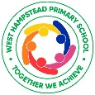
West Hampstead Primary Curriuclum - A Guide for Parents in Nursery – Summer
Over the past year, we have been working on developing and improving our ‘West Hampstead Primary Curriculum’. This document shows you what children in Nursery will be learning in the Summer term.
- Teach our pupils to learn well
- Teach our pupils how to lead happy, healthy, constructive lives, in which they can aspire and experience success
- Ensure broad and balanced knowledge of the world
- Teach our pupils to live well in a diverse world, as confident, responsible citizens

West Hampstead Primary Curriculum - Nursery
Our topic themes are carefully selected to expose all children to a wide range of ideas, language, learning opportunities and experiences. This enables them to make connections in their learning as well as providing a springboard to ignite their imagination, curiosity and creativity. |  |  | Every unique child will access these learning opportunities at their own level and make progress from their own starting points. Key thinking and learning skills linking to the prime areas of learning are developed through all topics.
In the Summer term we will be reading:
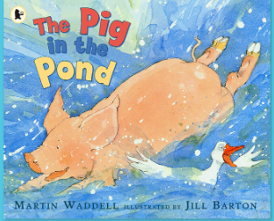
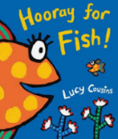
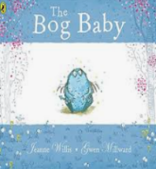
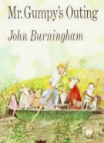
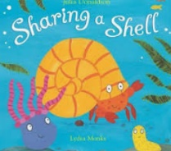

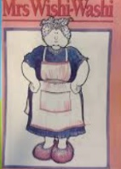
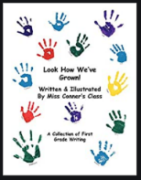
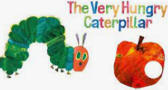
Our School Values  Last year, we worked with children, staff, parents and governors to develop our five core Beckford values, Aspiration, Responsibility, Resilience, Consideration and Community. These themes run through each of our topics. |  | Aspiration   | Responsibility   | Resilience   | Consideration   | Community  
Entry Point | Explore and Experience |  |  |  | Exit Point
- Preparing the children for a smooth transition to Reception | - Water  - Animals living on our planet  - Going to London Zoo |  |  |  | - Children are ready for Reception
PERSONAL, SOCIAL, EMOTONAL DEVELOPMENT | COMMUNICATION AND LANGUAGE |  | PHYSICAL DEVELOPMENT
Exploring and expressing our feelings and the feelings of others through social stories and weekly chat time  Care and concern for living things  Continue to develop friendships  Transition into new class / school | Explore Body Percussion, alliteration, rhythm and rhyme  Becoming familiar with different songs and rhymes, and starting to come up with their own  Pirate role-plays and games  Talking about life cycles and learning vocabulary associated with it  Gain confidence in talking about their ideas |  | Exploring balance  Hall sessions to develop gross motor skills  Continue to develop self-help skills  Continue to practise using different class equipment safely ex. Scissors  Carry on with Dough Gym  Support all children with any physical support they may need.  Act out physical changes in the life cycle  Nets and pincers to catch sea creatures
LITERACY | Nursery – Summer Topic |  | MATHEMATICS:
Making own story books  Sequencing events of a story.  Forming letters of their names  Building up vocabulary and asking questions  Making maps  Making shopping lists  Parents invited to read in their home language | Splash! |  | Developing an awareness of sequencing numbers  Recognising number to 10  Exploring shapes and patterns  Singing daily number and counting songs  Sorting and counting groups of objects (ex. shells and pebbles)  Counting forwards and backwards from a given number  Comparing sets of objects: which as more, which has less?
EXPRESSIVE ARTS AND DESIGN |  | UNDERSTANDING THE WORLD
Learning Pirate songs and pirate dances  Continue to use claves and other musical instruments  Movement sessions  Continue to do yoga weekly  Continue to construct with purpose in mind using blocks and other building material  Independent role-playing various parts of our key texts  Creating their own Under the Sea models, pictures and collages |  | Cooking from around the world.  Talking about the safe preparation of food.  Exploring the concept of floating and sinking  Investigating weight by asking the right questions  Using the internet to find out information  What makes you unique?  Special friends and times  Talking about the life cycle of caterpillars; how they change and how we change.

