W.H.P.S. Curriculum |  |  |  |  |  | Nursery
Spring 1: Where the Wild Things Are!    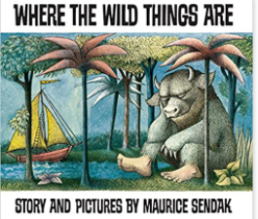  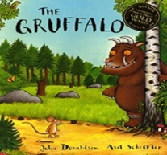  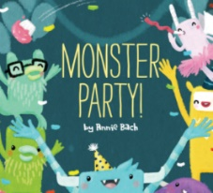  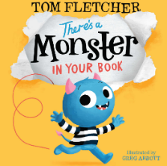 |  |  |  |  |  | Spring 2: Food, Glorious Food!  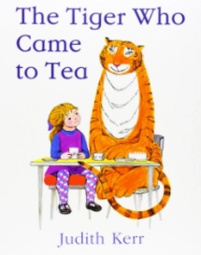  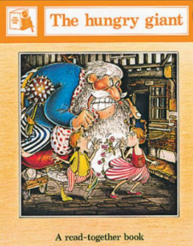  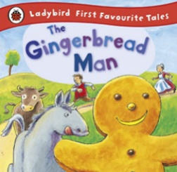
Aspiration   | Responsibility   | Resilience   | Consideration   |  | Community  
Our topic themes are carefully selected to expose all children to a wide range of ideas, language, learning opportunities and experiences. This enables them to make connections in their learning as well as providing a springboard to ignite their imagination, curiosity and creativity.
Every unique child will access these learning opportunities at their own level and make progress from their own starting points. Key thinking and learning skills linking to the prime areas of learning are developed through all topics.

Entry Point |  |  |  | Explore and Experience |  |  | Exit Point
Settling back after the holidays, resuming routines. Children reintroducing themselves to the group |  |  |  | Exploring our feelings |  |  | Looking at how we have grown

PERSONAL, SOCIAL, EMOTONAL DEVELOPMENT | COMMUNICATION AND LANGUAGE |  | PHYSICAL DEVELOPMENT
Explore feelings the feelings of others  Talking about fears, including those from stories  Discussing being responsible for our actions  What food do you enjoy?  Taking care of the environment around us. | Continue to explore instrumental and environmental sounds  Talk Boost groups to develop listening and speaking skills  Talking about our stories  Retelling stories |  | Using new tools safely ex. Chopsticks  Support all children with any physical support they may need.  Play cooperative games  Moving to music  Looking at ways to stay healthy  Practice cutting ex. When making sandwiches  Dough Gym
LITERACY | Nursery – Spring Topic |  | MATHEMATICS:
Access to books and other printed materials  Making our own books and lists inspired by our key texts (authors and illustrators)  Making story maps  Retelling stories using story props  Topic activities to experiment with mark-making and writing.  Inviting parents to share stories and rhymes in home languages. | Where the Wild Things Are; Food Glorious Food! |  | Providing children with daily reasons to count  Counting to 10 and beyond  Recognising numbers and ordering them  Practical indoor and outdoor activities that encourage counting and number recognition  Daily singing of number songs/rhymes  Practise using positional language  Practising problem-solving
EXPRESSIVE ARTS AND DESIGN |  | UNDERSTANDING THE WORLD
Continue to provide children with a wide-range of opportunities to express media, colour and texture  Using various construction materials to build and balance  Role-play opportunities  Learning to move in different ways  Singing food songs |  | Exploring different animal groups, habitats and creatures in our environment (class pet)  Exploring different foods, we like to eat and experiment with new foods from around the world  Cooking and baking: what is healthy?  Exploring other places and talking about where we are from, places we’ve visited  Looking at things in our environment that help us grow. Transport:  Caring for our environment. Transport: how do we get around?

