The West Hampstead Curriculum - A Guide for Parents in Nursery
Over the past few months, we have been working on developing and improving our ‘West Hampstead Curriculum’. This document shows you what children in Nursery will be learning throughout the year and what your child will be learning in the Autumn term. You will receive more information later in the year.
Intent - The West Hampstead Curriculum is designed to:
- Teach our pupils to learn well
- Teach our pupils how to lead happy, healthy, constructive lives, in which they can aspire and experience success
- Ensure broad and balanced knowledge of the world
- Ensure high levels of competence in the core subjects of English and maths
- Teach our pupils to live well in a diverse world, as confident, responsible citizens

West Hampstead Values:
We have worked with children, staff, parents and governors to develop our five core West Hampstead values , Aspiration, Responsibility, Resilience, Consideration and Community. These themes run through each of our topics.
The National Curriculum:
At our school the National Curriculum is statutory. It lays out the range of subjects we must teach and sets the standards pupils are expected to reach at the end of each key stage of learning. Our Schools Curriculum incorporates the National Curriculum and goes beyond it. We have adapted and extended the National Curriculum to meet the particular needs of our pupils and families. It is a curriculum designed to work for all in our community.
EYFS Curriculum:
The EYFS curriculum uses a broad selection of engaging core texts linked each half term to an overarching theme. The activities and experiences we plan are guided by the Educational Programmes set out in the DFE Statutory framework for the early years foundation stage and designed to enable all children to acquire the skills, knowledge and attitudes they will need by the end of the reception year.
Topic Enrichment
We believe that all topics should be memorable, engaging and exciting! So for each topic you will see that we have planned for:
an exciting entry point, opportunities for exploration through in depth research , exciting trips and an exit point that will often involve sharing work with our community.

The Values | Aspiration   | Responsibility  
 | - Creativity  - Curiosity  - Communication | - Citizenship  - Staying Healthy  - Organisation
Resilience   | Consideration   | Community  
- Confidence  - Independence  - Adaptable | - Kindness  - Empathy  - Respect | - Belonging  - Collaboration  - Relationships
West Hampstead Currculum Overview - Nursery
Our topic themes are carefully selected to expose all children to a wide range of ideas, language, learning opportunities and experiences. This enables them to make connections in their learning as well as providing a springboard to ignite their imagination, curiosity and creativity. |  |  | Every unique child will access these learning opportunities at their own level and make progress from their own starting points. Key thinking and learning skills linking to the prime areas of learning are developed through all topics.
In the Autumn term we will be reading:

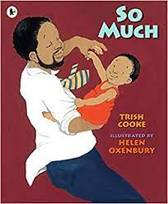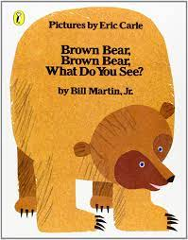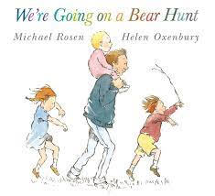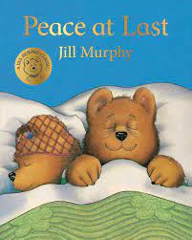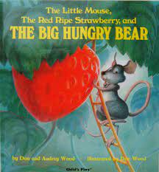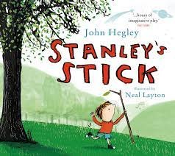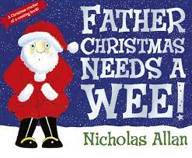

Our School Values  We have worked with children, staff, parents and governors to develop our five core West hampstaed values, Aspiration, Responsibility, Resilience, Consideration and Community. These themes run through each of our topics. |  | Aspiration | Responsibility | Resilience   | Consideration | Community
Entry Point | Explore and Experience |  |  |  | Exit Point
- Settling children in the nursery and welcoming their families. | - New environments and new adults |  |  |  | - A happy and successful ending to the first term.  - Christmas celebrations

Nursery Topic Map – Autumn Term
PERSONAL, SOCIAL, EMOTONAL DEVELOPMENT | COMMUNICATION AND LANGUAGE |  | PHYSICAL DEVELOPMENT
Transition into new class / school  Settling in/happy in school  Taking turns and playing co-operatively  Making friends  Gaining confidence  Learning the Golden Rules and how to follow them | Chat time (small groups and as a whole class activity)  Talk Boost groups to develop listening and speaking skills  Learning to follow simple instructions  Talking about themselves and their families  Answer simple inference questions about a story |  | Dough gym  Gross-motor movements, ball skills and using equipment  Self-help skills: dressing and feeding ourselves  Communicating our needs (going to the toilet, hunger etc)  Support all children with any physical support they may need.  Using tools such as scissors/pencils  Moving to music  P E sessions in the hall.
LITERACY | Nursery – Autumn Topic |  | MATHEMATICS:
Listening and joining in with stories in English and home languages  Joining in with repeated refrains  Introducing environmental and instrumental sounds  Mark-making and exploring tools and paper  Distinguishing between different marks  Recognising our names  Name writing | Stories and Rhymes |  | Learning number rhymes  Number games in play  Repeating numbers in order  Counting with 1-1 correspondence  Counting abstract things such as jumps, claps etc  Begin to use language of size  Interest in representing numbers  Interest in shape
EXPRESSIVE ARTS AND DESIGN |  | UNDERSTANDING THE WORLD
Explores colour and how colour can be changed  Introduce children to new mixed media e.g. glue, pens, paint, tape etc  Enjoys joining in with dancing and games  Imaginative play  Sing familiar songs  Workshop from Royal Academy of Music students. |  | Knows some of the things that make them special  Interest in lives of familiar people  Talk about similarities and differences in relation to family and friends  Festivals and celebrations  Introducing our weekly cooking/baking sessions from around the world  Knows Information can be retrieved from computers  Skills in making real life objects

